Image | 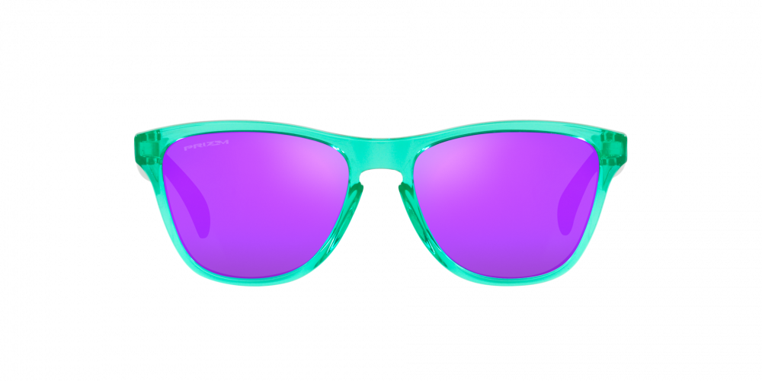
Brand | OAKLEY
Model Name | FROGSKINS™ XS SPIN-SHIFT
Price | RS 4499
PRODUCT DETAILS

